WASHINGTON PARISH COUNCIL MEETING

Draft MINUTES of the monthly meeting of Washington Parish Council held on Monday 3rd November 2025 in the Washington Village Hall (Doré Room) School Lane, Washington RH20 4AP

PRESENT: Cllr C. Brookes, Cllr B Hanvey, Cllr O. Jupp, Cllr T Keech, Cllr A Lisher (Chairman) and Cllr J Thomas.

IN ATTENDANCE: Cllr E. Beard (HDC) and Cllr J. Grech (HDC). Apologies received from Cllr P. Marshall (WSCC), and Cllr C. Fisher (HDC).

ALSO: Clerk to the Council. No members of the public were in attendance.

ABSENT: Cllr A. Dillaway.

The Chairman opened the meeting at 7:30pm.

FC/25/11/01 Apologies for Absence
The Council RESOLVED to accept apologies from Cllr Dillaway

It was agreed to bring forward agenda item 21 for the next item of business, under the Council’s
adopted Standing Orders 10(a)(iv) for reasons of expediency.

FC/25/11/02 Chairman’s announcement
The Chairman announced the resignation of Cllr Madeleine Shaw and that a Casual
Vacancy has been declared for the Heath Common Ward. The Council joined the Chairman in
thanking Cllr Shaw for her service to the community.

FC/25/11/03 Declaration of Members’ Interests and Dispensations.
None declared as defined under the Localism Act 2011 and the Council’s Code of Conduct for
the business of this meeting.

FC/25/11/03 Minutes of the last Full Council meeting
The Council RESOLVED to approve the minutes of the Full Council meeting held on
1st September 2025 with an amendment to the dates of the Committee meetings which are
held in November.

FC/25/11/04 Public Forum
There were no written or verbal representations other than those reported
elsewhere on the agenda and discussed at this meeting.

FC/25/11/05 County and District Councillors

WSCC Reports
None. It was noted that Cllr Marshall had given his apologies prior to the meeting.

HDC Reports
Cllr Beard and Cllr Grech reported on a number of matters including:

- the timeline for LGR in West Sussex
- HDC’s interest in supporting small business in village centres like Storrington to introduce a community toilet scheme.
- HDC is seeking ways to protect TPO trees threatened with felling by insurance companies.

The two District Councillors answered questions and agreed to find out the following:
- What is happening to the S106 monies for affordable housing, ring-fenced from the East Clayton Farm development, and how can it be accessed for local benefit?
- Similarly, how much of the HDC portion of CIL monies from the parish are being held, how is it being spent and how can it be accessed for local benefit?

The Chairman thanked Cllr Beard and Cllr Grech for their reports. They remained for the
planning items on the agenda.

FC/25/11/06 Planning applications, Decisions, Appeals and Compliance Matters

The Council discussed the following planning application:

DC/25/1584 - Barnards Nursery Rock Road Washington West Sussex
Permission in Principle for the demolition of existing structures / buildings and erection of up to
4no.dwellings.

The Council RESOLVED to make an objection because it is an inappropriate form of
development not in conformity with the Neighbourhood Plan and could create an unfortunate
precedent for further development.

Cllr Beard and Cllr Grech left the meeting at 7:58pm.

Planning Decisions:
The Council noted the WSCC decision to approve the following application with conditions:

WSCC/10/001/20 – Washington Sand Pit Hampers Lane Sullington RH20 3EX
The continuation of mineral extraction and the importation of inert material to enable the
restoration of mineral working at Washington Sandpit (Variation of conditions 1, 2, 4, 8, 19 and
22 of planning permission WSCC/009/18/SR to allow two further years’ extraction and
Restoration by 2028).

Compliance matters
None reported

FC/25/11/07 Actions and Matters Arising
The Clerk reported the following matters arising since the last meeting:

Washington Link Pathway
A meeting with the SDNPA ‘s to discuss progressing the Washington Bostal link pathway, is being
arranged by the attendees, Cllr Grech and Cllr Thomas, to be held later this month.

Allotment Tenancy Agreements
Plot Holders have been advised of the Council’s agreement on new terms and rent increases
from next January.

Safety inspections
Mr Trevor Cox will commence the Council’s safety inspections on 4th November.

All other matters were reported under other agenda items at this meeting.

The Council noted the updates and that Cllr Marshall is to be invited to the SDNPA meeting
about progressing a safe non-vehicular link from the Washington Bostal road to the South
Downs path.

FC/25/11/08 Interim Audit
The Council’s 2025.26 Interim audit report from Mulberry Local Authority Services Ltd was
eceived.

Following a review, the Council RESOLVED to comment that:

- Authorisation levels for Council expenditure by the Clerk or duly delegated committee, are considered to be at an appropriate level and would be reviewed by the Finance Committee if required.

- Meeting supporting papers would continue to be published and made available to the public within the ICO guidelines as appropriate.

The Council noted a successful audit report and thanked the Clerk for her work towards this.

FC/25/11/09 Internal Financial Controls
The Chairman of the Finance Committee, Cllr Keech, reported on his second quarter review
of the Council’s Internal Financial Controls for 2025.26 and that there were no issues to review.

The Council RESOLVED to note the report which was duly signed by Cllr Keech.

FC/25/11/10 Clerk’s Report

The Clerk reported on the following:
:
- Microsoft 365 and GOV.UK domain switch for the Council
GOV.UK emails for the Councillors will be activated after the Council meeting from 8th
December. The IT consultant from StarTech would distribute written login instructions
beforehand and give a brief presentation at the meeting.

Queries were raised by one of the Members and the Clerk agreed to seek responses
from Startech with a summary of the process.

- Council training opportunities:
The Clerk reminded Councillors of the following training dates previously distributed:

- Rights of Way Training 13th November 2025.
- New Councillor Training 25th November:
- Appraisal training 20th January 2026

It was noted that one Councillor has registered for the New Councillor training.
The Clerk requested others who are interested, to contact her before the registration
deadlines in order to secure their booking.

- Winter Readiness on the Highway – Member and Parish information briefing session

- October Employer Bulletin

- The Community Highways Scheme (CHS) Proposal: ‘Storrington & Sullington 20-MPH’
Supporting Document
This has been submitted by Storrington & Sullington Parish Council to the WSCC
Highways Authority for assessment., and if successfully shortlisted, there will be a public
Consultation through the formal CHS process administered by WSCC.

- A24/A283 Washington Roundabout - Local Safety Scheme
WSCC will consult the Council on this scheme after 27th October 2025. To be discussed
at the next Planning & Transport Committee meeting on 17th November.

The Council RESOLVED to note the content of the reports

FC/25/11/11 Committees and reports from Outside Bodies
The Council received and noted the following:

- The draft minutes of the meetings of the Planning & Transport Committee and OSRA
Committee both held on 20th October 2025 and published on the Council’s website.
- The meeting papers for the WSALC AGM to be held on 4th November.

The Chairman advised that there were no recommendations for consideration from the
Committee meetings. The Clerk had given apologies to WSALC on behalf of Cllr Thomas, the
Council’s WSALC representative, that he is unable to attend the AGM due to a prior
commitment.

FC/25/11/12 Neighbourhood Plan
The Council noted from the Chairman that there is no further update on the review of the
Storrington & Sullington and Washington Neighbourhood Plan because the Steering Group is
still waiting to find out what is happening with the Horsham District Local Plan.
.
FC/25/11/13 Parish Community Infrastructure Levy (CIL) and Section 106 funding
The Council received the latest 2025.26 quarterly CIL and S106 reports from HDC for
the parish.

The Chairman reported that £31,560.28 CIL from the East Clayton development
DC/23/070 had been paid by HDC into the Council’s community account the day of this
meeting.

The Council RESOLVED to note the reports and that they will be included in the agenda
for review at the Finance Committee meeting on 17th November.

FC/25/11/14 Urgent Matters
None reported.

FC/24/11/15 Delegated decisions
The Council was previously advised of the following delegated decision by the Clerk in
consultation with the Chairmanship, in accordance with the Council’s adopted Financial
Regulations 5.10 and 5.15:

- Purchase of replacement laptop, accessories and set up from StartTech, Pulborough,
for the sum of £1,649.39 plus VAT on 20th October 2025 with 3-year warranty.
REASON: existing laptop is beyond economic repair and replacement required
urgently in order to conduct Council business.

It was reported that the quote from another provider had also been considered. It had been
agreed that StarTech was the preferred contractor because they are local and known to the
Council, providing prompt, reliable and knowledgeable service.

The Council RESOLVED to ratify the delegated decision by the Clerk.

FC/25/11/16 Financial
The Council RESOLVED to approve the following payments schedule for invoices
totalling £8,920.06 to be authorised online by Cllr Keech and Cllr Lisher.

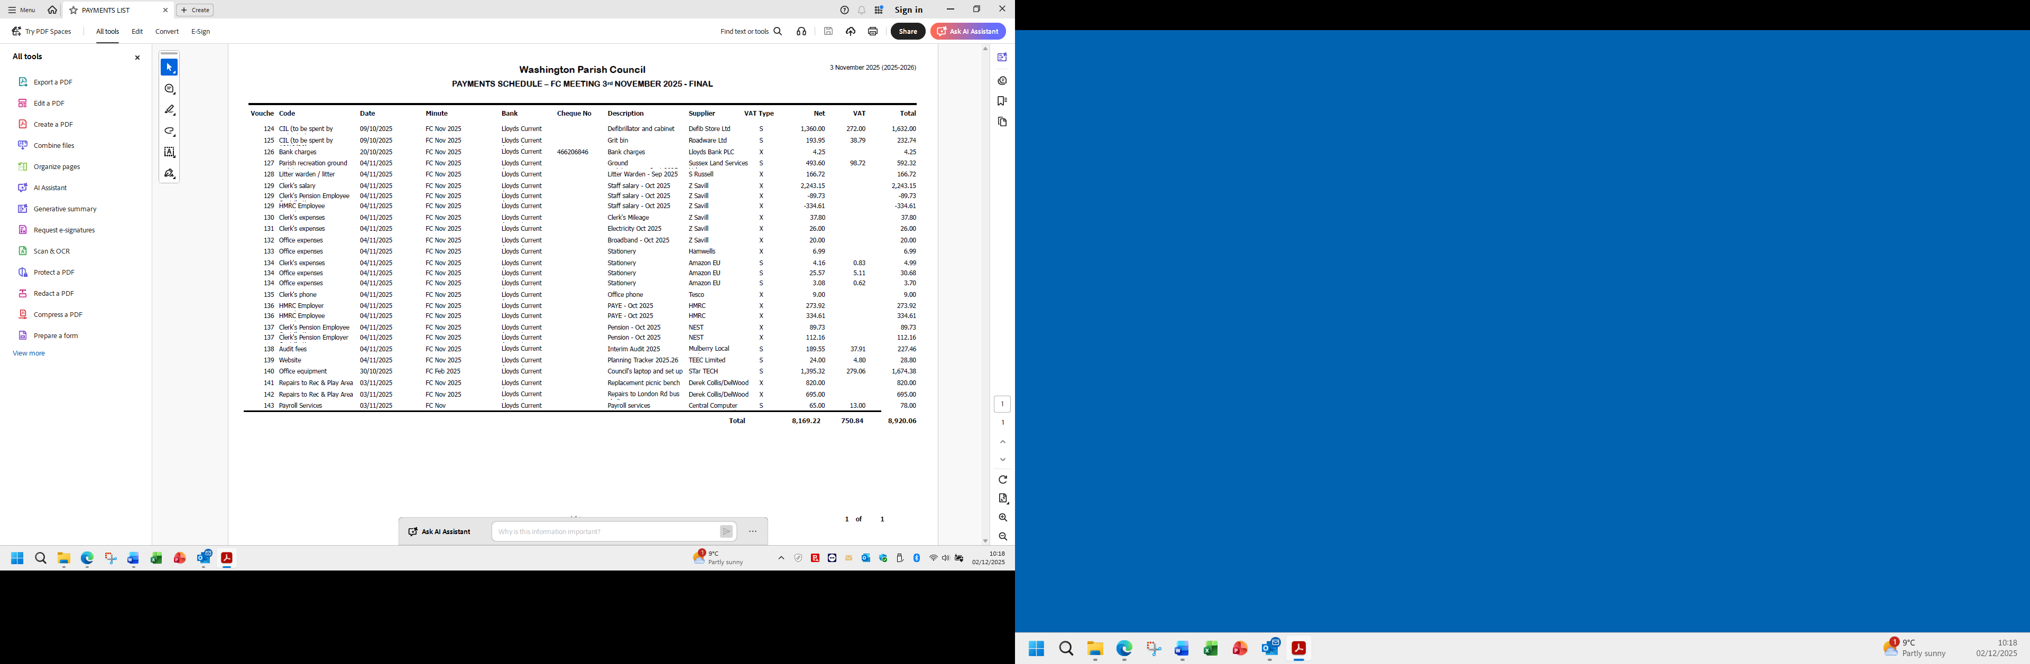 Income
The Council RESOLVED to note the following receipts totalling £2,873.04 since the last meeting:

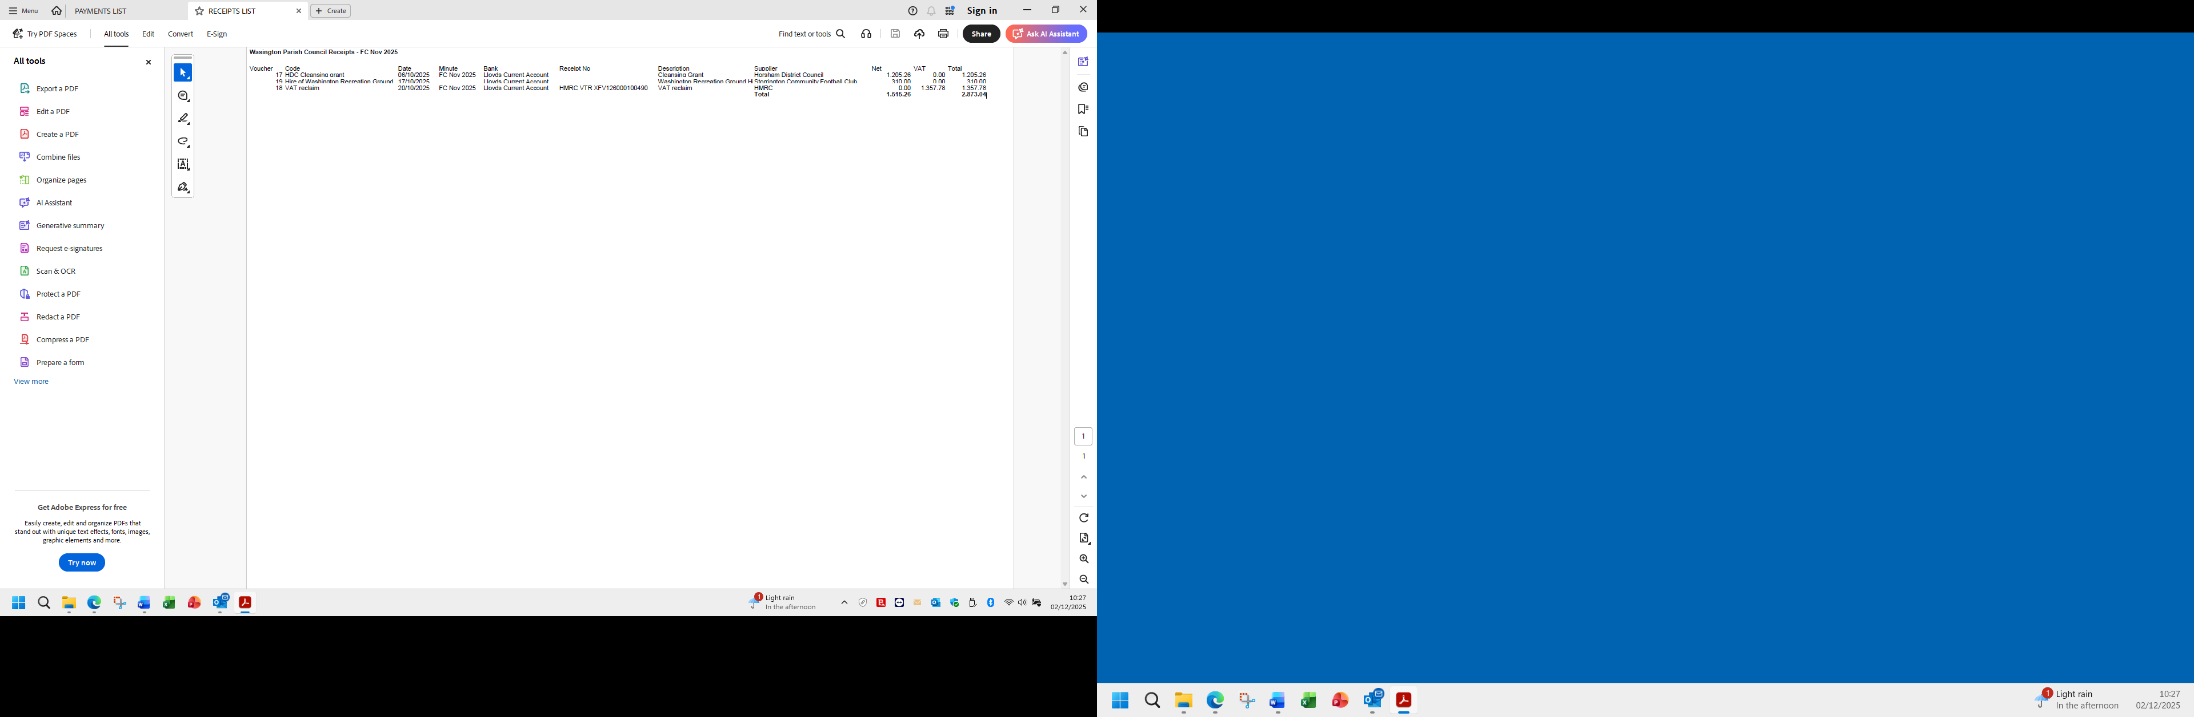

To Report bank reconciliations on 20th October 2025:
The Council RESOLVED to note the bank reconciliations of the Council’s following accounts:
Lloyds community account: £ 12, 197.44
Nationwide Business Savings: £ 71,776.38
Redwood Business Savings: £ 50,000
Total balance on all accounts: £ 133, 973.82

To Consider quotations
None to consider

To Review and Agree staff banking card
The Council reviewed and RESOLVED to delegate authority to the Clerk to apply to Lloyds for a pre-payment card for emergency expenditure and office sundry items not on account. The amount to be limited to £500 in accordance with the adopted Financial Regulations 5.15 without referral to the Chairmanship, within the adopted budget.

FC/25/11/17 Reserves
The Council reviewed its current cash position since the last bank reconciliation, noting it has
increased to £165,534.10 due to the receipt of £31,560.28 CIL monies for the care home
development at the former Old Clayton Kennels site.

Cllr Keech proposed that the Council transfer £15,000 from the Lloyds account to the
Nationwide account to maximise returns on the savings. The Clerk advised on reducing the
transfer amount by around £1,777 so that the Nationwide balance does not exceed the £85,000
FSCS protection of £85,000. Cllr Keech suggested it would be safe for the relatively short
time before the Council would need to review its cash position again next January.

The Council RESOLVED to agree Cllr Keech’s proposal to transfer £15,000 to the Nationwide
account. Clerk to arrange the transfer with the Schedule of Payments.

FC/25/11/18 Asset Registers
The Council reviewed its asset registers since the recent purchases of a defibrillator, cabinet and
grit bin at John Ireland Way, and a replacement picnic bench for the Play Area held separately in
trust to the Washington Recreation Ground Charity.

The Council RESOLVED to approve and adopt the amended registers as follows:

- Parish Council Asset Register: £36,028.77, an increase of £1,524.77 since last adopted.
- Washington Recreation Ground Asset Register: £96,305.89, an increase of £325 since
last adopted.

The Council further RESOLVED to delegate authority to the Clerk to arrange payment of
any increases in the Council’s combined insurance policy for both registers.

FC/24/11/19 Washington Recreation Ground Charity: Annual Return
The Council RESOLVED to defer reporting the WRGC Annual Return 2024/25 to the next
appropriate meeting, to be submitted to the Charity Commission before end of next January.

FC/24/11/20 Correspondence
The Council noted the following correspondence previously distributed:

Request from a resident for parish council’s support to remove St George’s flags from two
WSCC streetlights on the Steyning Road, near Washington A24 roundabout
The Clerk reported on concerns expressed in an email from a resident, regarding the display of
the national flags in the parish, thought to have arisen from protest activity both nationally and
locally.

It was noted that the resident has been advised that the matter was reported to WSCC which
owns the lights and the flags have since been removed. The Clerk advised that WSCC has
warned the public not to paint on the Authority’s street furniture or hang flags from their street
lights, being contrary to the Highways Act 1980 and potentially dangerous. A WSCC reporting
link would be shared and it was agreed that anyone feeling intimidated by these flags should
report the matter to the police.

- Big Church Festival - Washington PC
The Event and Production Manager of the Big Church Festival at Wiston has written
apologising to any resident inconvenienced by the event in August, particularly
emanating from traffic.

In his email, the Manager had suggested attending a future Council meeting to hear
local concerns and to invite comments on the festival’s working plans for next year’s
event. It was noted that the Clerk has invited the Manager to give a brief
presentation at the next Planning & Transport Committee meeting. A response is
pending.

- Georges Lane resurfacing- complaint from a member of the public
A resident has written to complain about recent repairs to the bridleway surface of
the southern end of Georges Lane which serves the National Trust car park. It was
noted that holes which had been patched up by the National Trust were already
breaking up and that the resident had criticised the efforts to maintain the road as a
waste of thousands of pounds. The resident had sought assurance that the Council
had not contributed to funding the repairs and this was confirmed by the Clerk.

The Council noted the contents of the email and that complainants of the track
should be referred to the National Trust which maintains it, and also WSCC which
has statutory responsibility for it as a public bridleway.

The Council noted all other correspondence previously circulated.

FC/24/11/21 Chairman’s announcements
There were no Chairman’s announcements

FC/24/11/22 Dates and Times of the next meetings
The Council noted the following meeting dates and times. A Member queried the date for
the December meeting and the Clerk advised that this is always held on the second Monday to
allow for the budget review:

Planning & Transport Committee: Monday 17th November 6:30pm
Finance Committee: Monday 17th November 7:15pm
OSRA Committee: Monday 17th November 8:00pm
Full Council Meeting: Monday 8th December 7:30pm

FC/24/11/23 Confidential Session
The Council RESOLVED to agree that under the Public Bodies (Admissions to Meetings) Act
1960, the public and representatives of the press and broadcast media be excluded from the
meeting during consideration of the following items of business as publication would be
prejudicial to the public interest because of the confidential nature of the business to be
transacted.

FC/24/11/24 Washington Recreation Ground Charity: Rampion 2 legal matters
The Council reviewed correspondence from Rampion (25th October 2025) seeking to progress
the voluntary terms on cable access on the Recreation Ground to serve the Rampion 2
windfarm development off the Sussex coast.

Correspondence from the Council’s Agent was also circulated, reporting on changes to the
access terms agreed by Rampion and advising the Council on next steps.

It was noted that the Council’s Agent will review the terms once more. The amended terms
will be sent to the Council’s Solicitor for approval before asking the Council to approve.

Following a discussion, the Council RESOLVED to agree the amendments and defer to
the Agent for his review and to the Solicitor, before being presented to the Council for final
approval

There being no further business to conduct, the Chairman closed meeting at 20:52hours.

Signed…………………………………….

Dated……………………………………..

